

**FIRE SAFETY AND EMERGENCY EVACUATION POLICY**

**SoCo Music Project**

**Covering Planet Sounds**

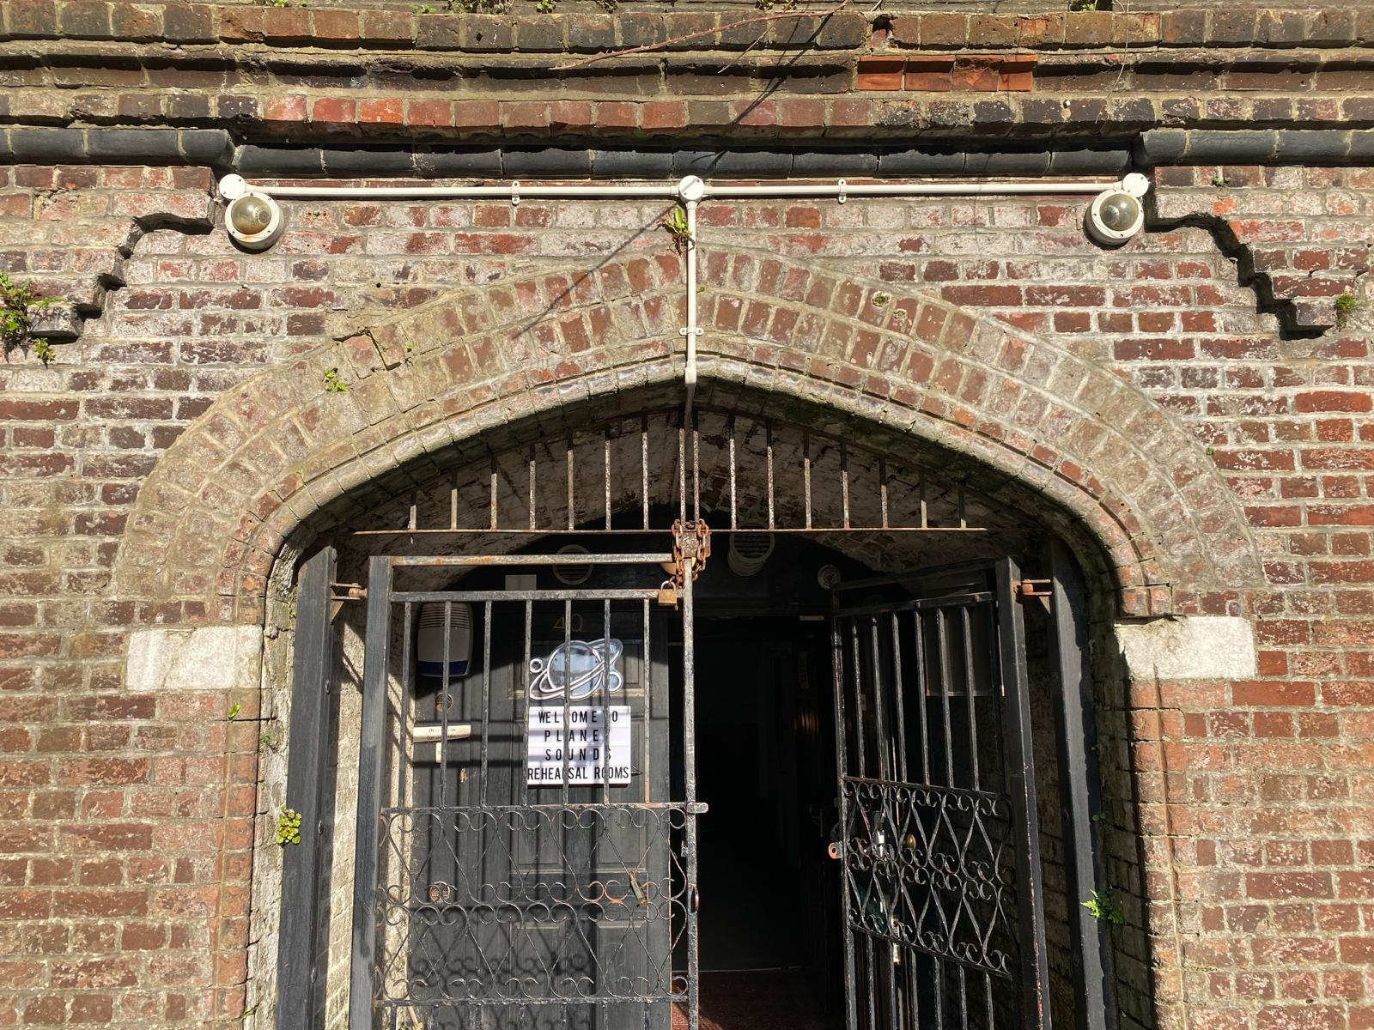



| Date policy became effective: | 26th February 2024 |
| --- | --- |
| Period of review: | Annually |
| Next review date: | 26th February 2025 |
| Person responsible for implementation and monitoring: | Fire safety manager  Fire marshals |

# Fire Safety

## Introduction

Our priority is to minimise the risk to life and to reduce injury by maintaining the physical fire

safety of Planet Sounds (“our premises”), in ensuring that staff, participants and visitors do not add to the fire risk and through safe evacuation of our buildings if a fire breaks out. The fire

safety policy, procedures and risk assessments at our premises are designed to help our community to respond calmly and effectively should fire break out in our building.

Fire Safety Manager

The studio manager is the designated fire safety manager (supported by trained fire marshals) and is responsible for ensuring that:

* The Fire Safety Policy is kept under regular review by our Trustees.
* The Fire Safety Policy is promulgated to the entire organisation.
* Everyone in our premises (including visitors and contractors) are given clear instructions on where they should go in the event of fire.
* Records are kept of the fire safety training given to staff.
* Procedures and arrangements for emergency evacuation are regularly tested, including the maintenance of escape routes, signage and emergency lighting.
* Fire risk assessments are regularly reviewed and updated.
* Fire prevention measures are followed.
* Fire procedures and risk assessments are reviewed on each occasion that the building is altered, when new buildings are acquired or when there has been a significant incident.
* Records are kept of all fire evacuation practices.
* Records for the installation and maintenance of fire prevention systems and equipment are kept.

# Fire Safety Procedures

## Emergency Evacuation

* If you discover a fire, raise the alert by immediately giving the shouted warning of fire.
* As soon as the alarm is sounded, leave the building in an orderly manner, walk, do not run.
* If you are responsible for a session or participants, ensure they leave quietly with you.
* Follow the designated fire evacuation route to the nearest available safe exit.
* Do NOT attempt to fight the fire unless you have had specific training in fire-fighting.
* If you are trapped in smoke, stay close to the floor where the air may be cleaner and cover your nose and mouth with a wet cloth if possible.
* If a door feels hot, do not open it, as it probably means that there is a fire on the other side. Do not touch the door handle, always first check for heat on the handle by quickly brushing the back of your hand against it.
* Never go back for any possessions or for any reason.
* Assemble at the relevant fire assembly point - College Street Car Park.

### Once outside

* Stay outside and do not allow anyone to re-enter the building.
* Roll-call is immediately taken by the senior staff member in charge.
* Account for all occupants of the building; relay names and information about the possible location of anyone missing to the Fire Services as soon as possible.
* fire marshal or other responsible staff to:
  + Call 999 Fire Services (and ambulance services as appropriate)
  + Inform Senior Leadership Team.

### Your response is vital

* Remain quiet and support senior staff in carrying out an accurate role call as quickly as possible. Stay together and do not wander off.
* Move calmly to a further place of safety if instructed to do so.
* The Fire Evacuation Procedure attached to this Policy is located at key points in our premises

## Briefing New Staff

All new staff to SoCo are instructed on the emergency evacuation procedures as part of their Health & Safety Induction. They are shown where the emergency exits, escape routes and outside assembly points are located. It is the responsibility of the area lead to check that all new staff are conversant with these areas after induction is complete.

Fire action notices are displayed on the walls of rehearsal rooms, offices and in all escape routes.

No one should attempt to use a fire extinguisher unless they have been trained in its use.

## Visitors and Contractors

All visitors are required to sign in and out with the office. They are made aware of the emergency evacuation procedure and the assembly point relevant to their visit.

When large numbers of visitors are at our premises (for events, shows, exhibitions etc) a brief announcement is to be made prior to the event advising visitors of the location of the emergency exits that they should use in the event the fire alarm should sound during the event.

## Personal Emergency Evacuation Plan (PEEP)

In the event that either staff, participants or visitors have specific access needs, then a one to one PEEP assessment is carried out and recorded.

For participants, the PEEP is completed by the fire safety manager or practitioner leading the relevant programme and a copy of the PEEP is passed to fire marshals and kept in the office.

The PEEP should be reviewed at least quarterly (i.e after the length of one programme cycle) or after a significant change to ensure it captures all relevant details.

Staff PEEPs are to be completed by the manager of the member of staff concerned and are to be reviewed quarterly or after a significant change.

## Practitioners and Area Leads

Delivery staff are responsible for escorting participants safely out of the building in silence and in an orderly fashion. They are responsible for conducting a roll call on arrival at the assembly point, and for ensuring that the name of anyone who cannot be accounted for (and, if possible, their likely location) is passed immediately to the fire safety manager. It is the responsibility of fire safety manager to ensure that this information is passed to the Fire and Emergency service as soon as they arrive.

Area leads are responsible for ensuring their staff are aware of the fire evacuation process and are to ensure their staff undergo an annual fire evacuation practice within their working area. They are to pass records of the practice and attendees the administrator. In the event of a fire, they are responsible for conducting a roll call on arrival at the assembly point, and for ensuring that the name of anyone who cannot be accounted for (and, if possible, their likely location) is passed immediately to the Fire and Emergency service as soon as they arrive

On no account should anyone attempt to enter, or return to, a burning building.

## Fire Marshals

Studio staff are trained as fire marshals and are deemed ‘competent persons’ who have been trained to provide ‘safety assistance’ in the event of a fire.

They are competent in the use of fire extinguishers, are capable of extinguishing small fires, receive regular refresher training and staff new to the role receive training as part of their induction. They have some knowledge of fire prevention and are able to identify possible fire hazards to prevent fire from occurring.

In the event of a fire alarm sounding, they are to conduct a basic internal building search/sweep of their area of responsibility to ensure, as far as is practical, that all occupants have evacuated and are accounted for.

## Staff/Visitors and Participants

Staff must cooperate with the employer or other authorised persons to enable legal obligations to be fulfilled in respect of fire safety measures. No one should maliciously interfere or knowingly allow others to interfere with a fire alarm system, fire extinguisher or equipment, or block escape routes and/or fire exits. Other than in respect of notified tests, all staff, participants and visitors must follow the fire evacuation procedures.

## Fire Practices

At least one daytime fire evacuation practice is held annually. These practices, combined with a programme of inducting new staff with emergency escape procedures and the presence of trained fire marshals, help to ensure that our premises are safely evacuated in the event of a fire.

## Fire Safety & Prevention Measures

The following measures are in place:

### Escape Routes and Emergency Exits

* Fire notices and evacuation signs are displayed in rehearsal rooms, offices and in all escape routes.
* Fire extinguishers and smoke/heat detectors are located in every room in accordance with the fire safety regulations.
* Fire alarm systems are automatically activated when smoke/heat builds up beyond safe levels.
* Steps, passages and emergency exits are illuminated by emergency lighting.
* The fire alarm master panel for the alarm system is located in the main entrance to Planet Sounds, on the left as you enter the final set of doors.
* Alarms sound in all parts of the building (red flashing lights with vocal sounders).
* It is the responsibility of all staff to keep fire routes and exits clear at all times.
* The fire safety manager carries out regular inspections of escape routes.
* The alarm system is tested weekly and serviced annually by a BAFE approved contractor.
* Emergency lighting is tested at three monthly intervals and a three hour discharge test is carried out annually.
* Fire extinguishers are serviced annually by a BAFE approved contractor.
* Records of all tests are kept in the office.
* Plans showing the location of electricity shut off points are displayed in the emergency information folder located by the main alarm panel at the entrance.
* The kitchen area is fitted with a combined heat and smoke detector unit.

### Electrical Safety

* Our premises have current electrical test certificates. We use NICEIC qualified electrical engineers to inspect and maintain our electrical installations.
* Regular portable appliance testing is undertaken by the studio staff. Records of all tests are kept in the office.
* Non-essential electronic equipment should be switched off at the end of every day.
* The individual in charge of closing should check that all kitchen equipment is switched off at the end of the day.

### Rubbish and Combustible Materials

* Flammable rubbish is stored away from the building and disposed of appropriately.
* Combustible materials used in maintenance or other operations are stored in flame-proof cupboards.

## Fire Risk Assessment

Our Fire Risk Assessment meets the requirements of the Regulatory Reform (Fire Safety) Order 2005 (the FSO).

The most recent visit was carried out 19th May 2023.

Fire safety inspections are carried out annually.

Fire risk assessments are reviewed if significant changes are made to the interior of our premises, if new buildings are acquired, or if there has been a significant incident.

Copies of fire risk assessments and fire safety inspections are available for all staff, together with this policy. Any comments or suggestions for improvement can be directed to the administrator.

## Emergency Evacuation in Response to a Known or Unknown Threat

### Threats

* The success or failure of an evacuation rests on the cooperation of staff, participants and any visitors.
* Any threats received by staff must be logged and details immediately passed to the senior member of staff on site.
* Senior staff will assess the threat, consider if the crisis management plan should be implemented, agree any follow-on actions and/or contact emergency services as required. The crisis management plan may be instigated at any point.
* If a search is considered necessary, a search of the site should be carried out to determine the nature and location of the threat. The senior member of staff will decide if the site should be evacuated.
* Action should be taken to prevent anyone unwittingly entering the building after an evacuation.
* All details of threats, regardless of the outcome, must be logged and the log maintained by the administrator.

### Security Searches - Procedure

The aim of the search is to seek potential hazards, such as fire risks, suspicious packages etc, and also to ensure that the site has been fully secured i.e. doors closed and locked.

* Any search performed should include all rehearsal rooms and offices, corridors, and toilet facilities.
* If a suspicious item is found, then the area lead must be informed immediately.
* Suspicious items must not be touched or moved by search staff and the immediate area must be cleared of all personnel. As the location may be the scene of a crime, any witnesses or staff who worked in the area must be identified and this information given to the emergency services. Nothing in the area should be disturbed, as vital evidence may be lost.
* Any advice or directions given by the police, fire brigade or others in a position of authority must be followed.

## 

| **Fire Evacuation Procedure** |
| --- |

## 

| **General Emergency Evacuation Plan for:** |
| --- |
| Planet Sounds, 40 Terminus Terrace, Southampton, SO14 3FE  02380 334040 |
| Plan date: 26/02/2024 |
| Review date: 26/02/2025 |

| **Sound of the alarm** |
| --- |
| The sound of the alarm will be:  A continuous warning siren with red flashing lights. |

| **Raising the alarm** |
| --- |
| In the event of a fire:  If the fire is discovered by a staff member or a visitor notifies a staff member of a fire, the alarm will be raised by: manual warning  If fire is detected by automatic detectors, this will trigger the fire alarm |



| **Nominated People** |
| --- |
| Fire safety manager:  Aidan Cooper  Fire marshals:  Craig Lockwood  Andrea Resino Martin |



| **Action staff should take on hearing the alarm** |
| --- |
| The following actions will be taken upon the fire alarm being sounded/raised:   * The fire safety manager or fire marshals will take charge and lead in the fire evacuation * Dial 999 and request attendance by the Fire Service. Staff member gives their name, name of building, building address (as detailed above), contact number and details of fire * Staff will commence evacuation of the building – ensuring this is done in a calm and orderly manner, providing assistance to those needing additional help in evacuating * Separate ‘Personal emergency evacuation plans’ (PEEPs) are in place for staff and known visitors with additional needs as well as ‘General emergency evacuation plans’ (GEEPs) for members of public who may visit the building. Both these will be implemented as appropriate * Staff to sweep building to ensure all areas are clear if safe to do so and ensure all doors are closed on the way out * If safe to do, electrical mains should be switched off before leaving the building. The location of these are detailed below * to ensure nobody re-enters the building until confirmed safe to do so by the Fire Service * Meet at assembly point and check all contractors and staff members are accounted for to liaise with Fire Service upon their arrival |



| **Escape routes** |
| --- |
| The escape routes from the building are:  1. The main entrance to Planet Sounds  2. The fire escape in the second arch  Both are shown in image below |

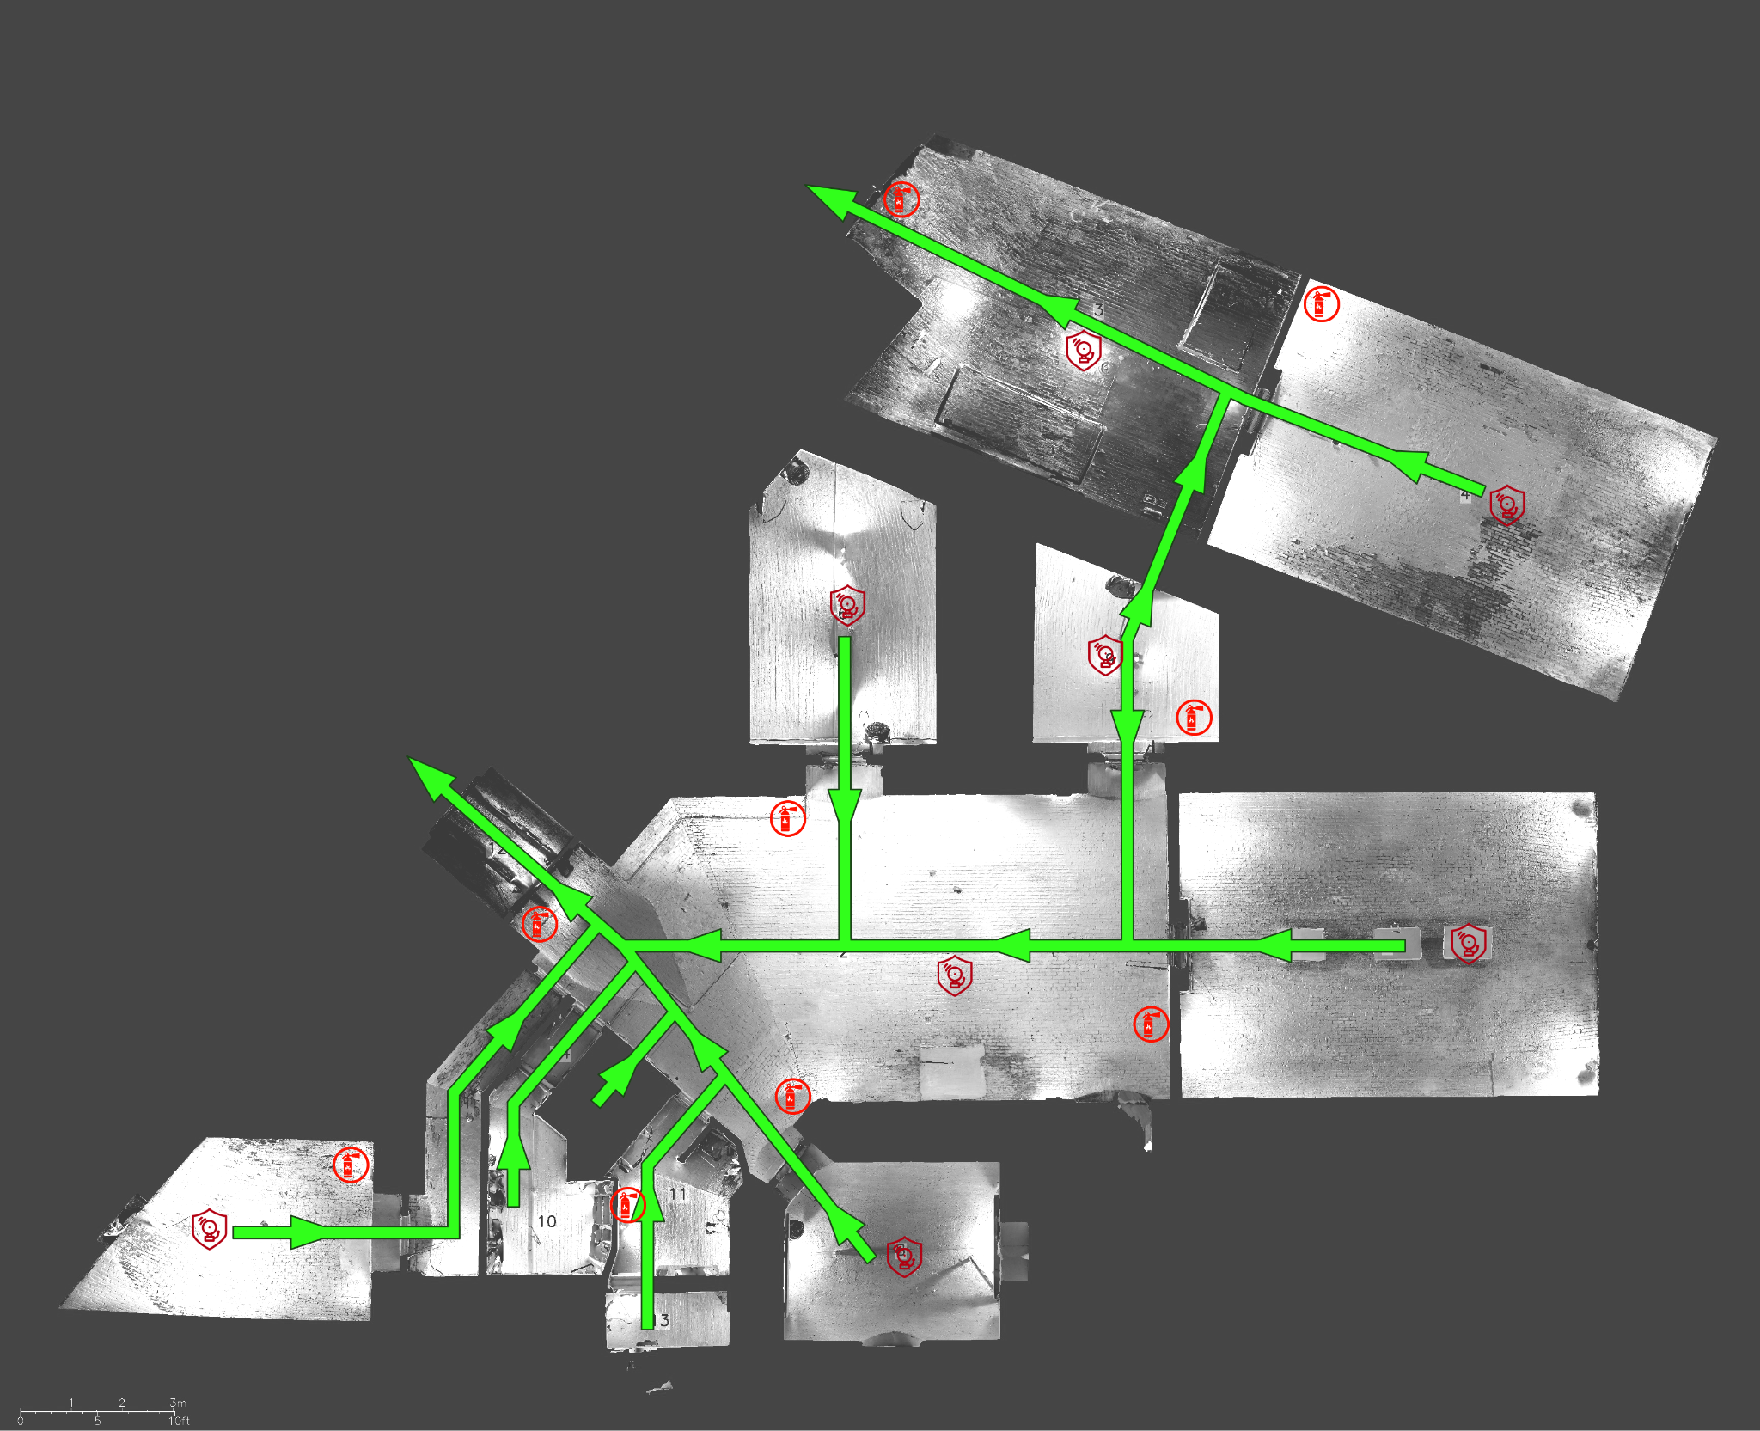

| **Fire assembly point** |
| --- |
| The assembly point is: College Street Car Park |



| **Fighting fires – Extinguisher use** |
| --- |
| Fire extinguishers will only be used where:  Staff have received training and feel confident in their use Where it is deemed safe to do so i.e. there is a clear means of escape, fire is small  **Personal safety always takes priority and, if in any doubt, staff should not attempt to extinguish a fire** |

| **Location of key safety hazards or other fire related equipment** |
| --- |
| Mains fuse box: The second arch, a grey cabinet near the fire exit door  Mains water inlet: The kitchen  Location of fire alarm panel: The main entrance to Planet Sounds, on the left as you enter the final set of doors. |

| **Number of staff needed to carry out evacuation plan** |
| --- |
| To implement the evacuation plan, one trained member of staff is needed on duty at all times |

| **Equipment needed to effect the emergency plan** |
| --- |
| Mobile phone  Evacuation pack including torch, hi-visibility tabard, evacuation chair, heat packs, rain ponchos, emergency information folder  Located by the main alarm panel at the entrance |



| **Responsibilities** | |
| --- | --- |
| For ensuring plan is up to date | Administrator |
| For ensuring adequate staff are on duty to carry out the evacuation plan | Area lead |
| For training staff on the evacuation plan and in their roles and responsibilities | As above |

